**Lab W1D3**

**Question 1**

Algorithm beautiful(A, n)

Input: An integer array A of size n

Output: the array with each element doubled

for i from 0 to n - 1 do

A[i] = A[i] * 2

end for

return A

**Question 2**

2^n, 2^(n + 1), 2^(2n), 2^(2^n )

**Question 3**

|  |  |
| --- | --- |
| **Time Complexities** | **Algorithm** |
| O(1) | Print Out Constant Number |
| O(log n) | BinarySearch |
| O(n) | FindMax |
| O(n log n) | Merge Sort |
| O(n^2) | Bubble Sort |
| O(n^3) | MultiplyMatrix |
| O(2^n) | Fibonacci |

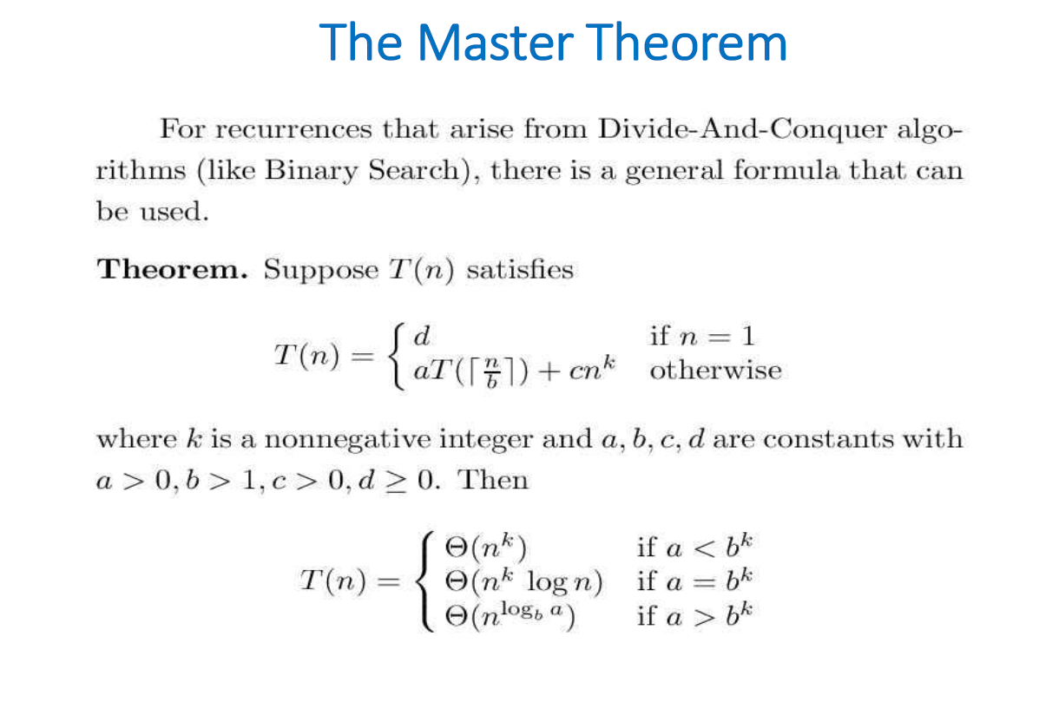

Fib(n)=Fib(n−1)+Fib(n−2)for n≥2

Fib(0)=0,Fib(1)=1

For the Fibonacci recurrences, the formula will be as below

T(n)=T(n−1)+T(n−2)+O(1):

It does not fit into the standard form required by the Master Theorem.

So, we cannot apply Master Theorem.